1)
import java.util.*;
class Earthquake{

public void Danger(float meas){
if(meas>0&&meas<=3){
System.out.println("no worries");
System.out.println("you are safe");

}
if(meas>3&&meas<=6){
System.out.println("low danger");
System.out.println("be in a open place");
}
if(meas>6&&meas<=9){
System.out.println("moderate danger");
System.out.println("got under a strong building ");
}
if(meas>9&&meas<=12){
System.out.println("high danger");
System.out.println("vacate the place immidiately");
}

if(meas>12){

throw new ArithmeticException("application crashed");
}
}

public static void main(String[] args){
Scanner sc=new Scanner(System.in);
System.out.println("E.pavan kumar reddy\n51834760");
System.out.println("enter the measurement of earthquake");
float measurement=sc.nextFloat();
Earthquake o=new Earthquake();
o.Danger(measurement);

}
}
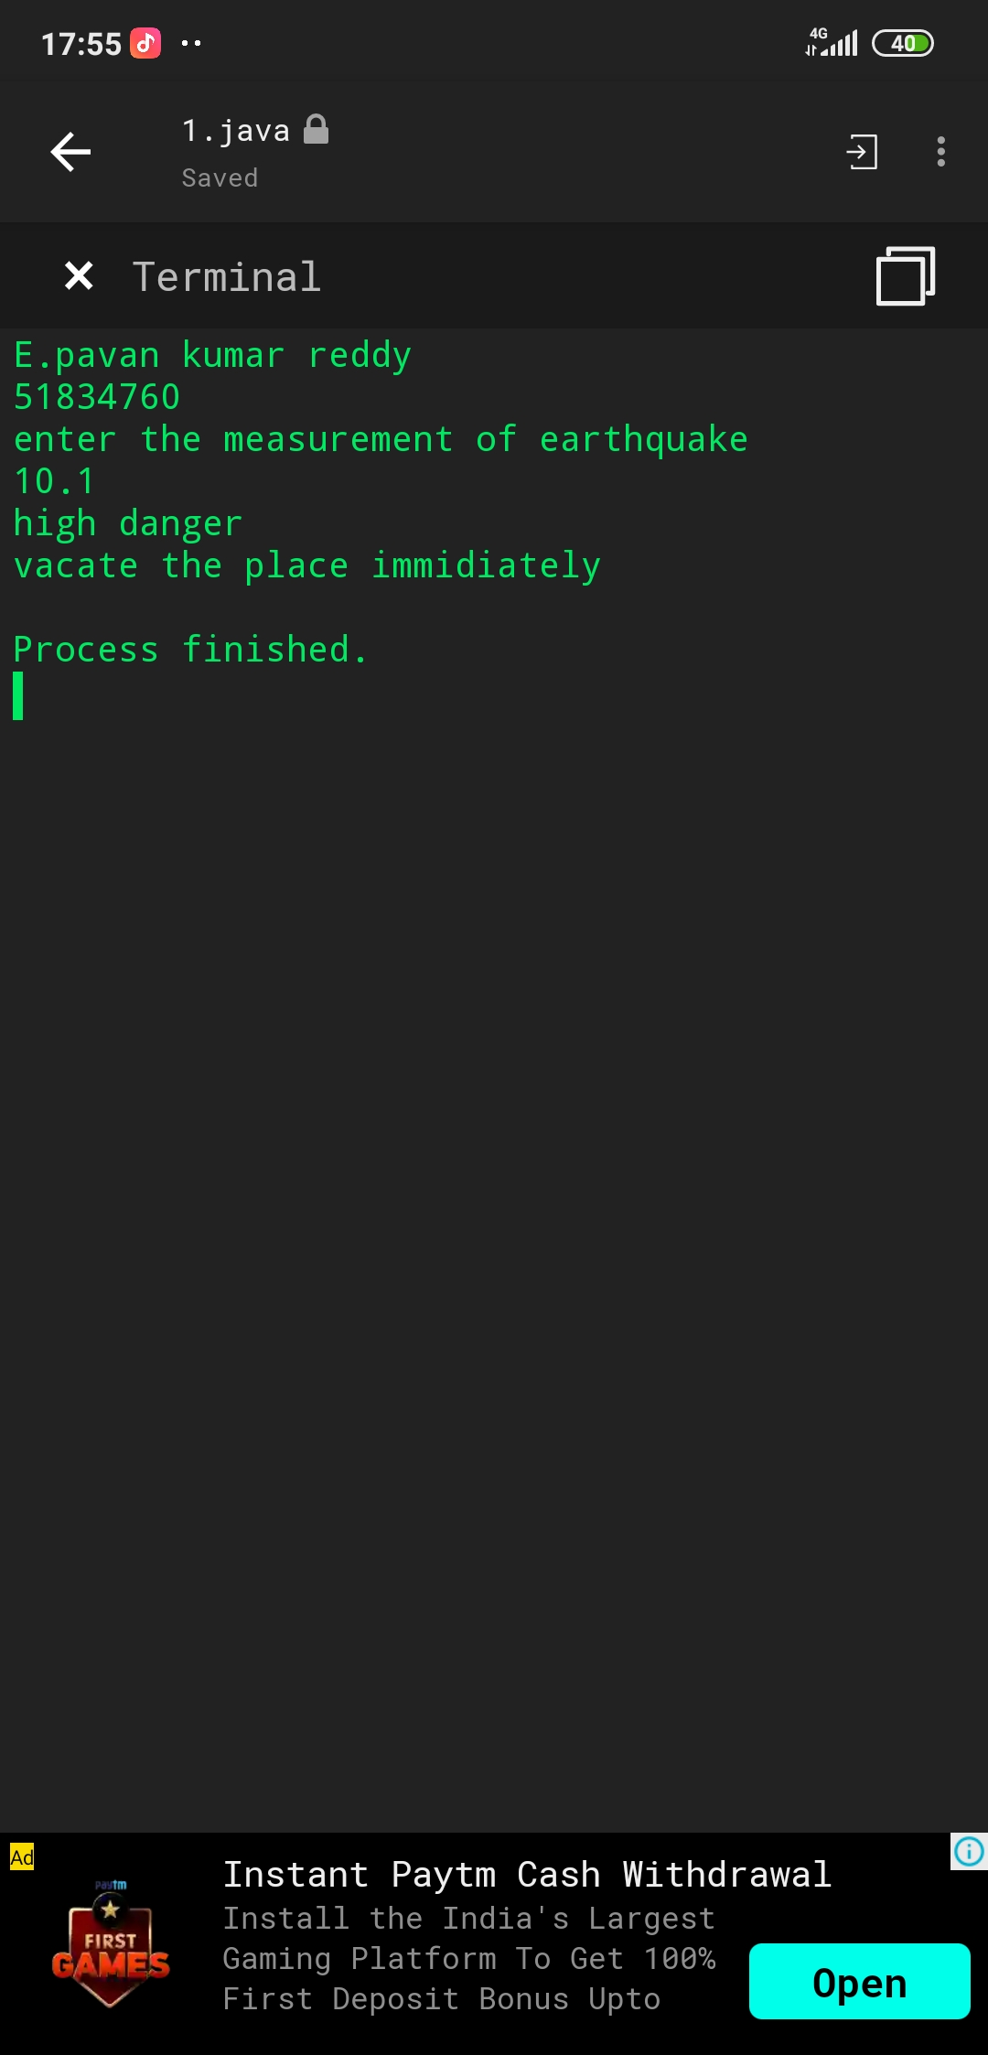

2)
import java.util.*;
class Pavan{
public static void main(String args[]){
Scanner sc=new Scanner(System.in);
System.out.println("e.pavan kumar reddy\n51834760");
System.out.println("input: ");
int num=sc.nextInt();

int tem=num;
int mun=0;
System.out.println("enter number to remove");
int a=sc.nextInt();
int rem=0;
int count=0;
while(tem>0) {
tem=tem/10;
count=count+1;
}
while(num>0){
rem=num%10;
mun=mun*10+rem;
num=num/10;
}
System.out.println("output: ");
for(int i=0;i<count;i++){
rem=mun%10;
if(rem==a){

}
else{
System.out.print(rem);
}
mun=mun/10;
}
}
}
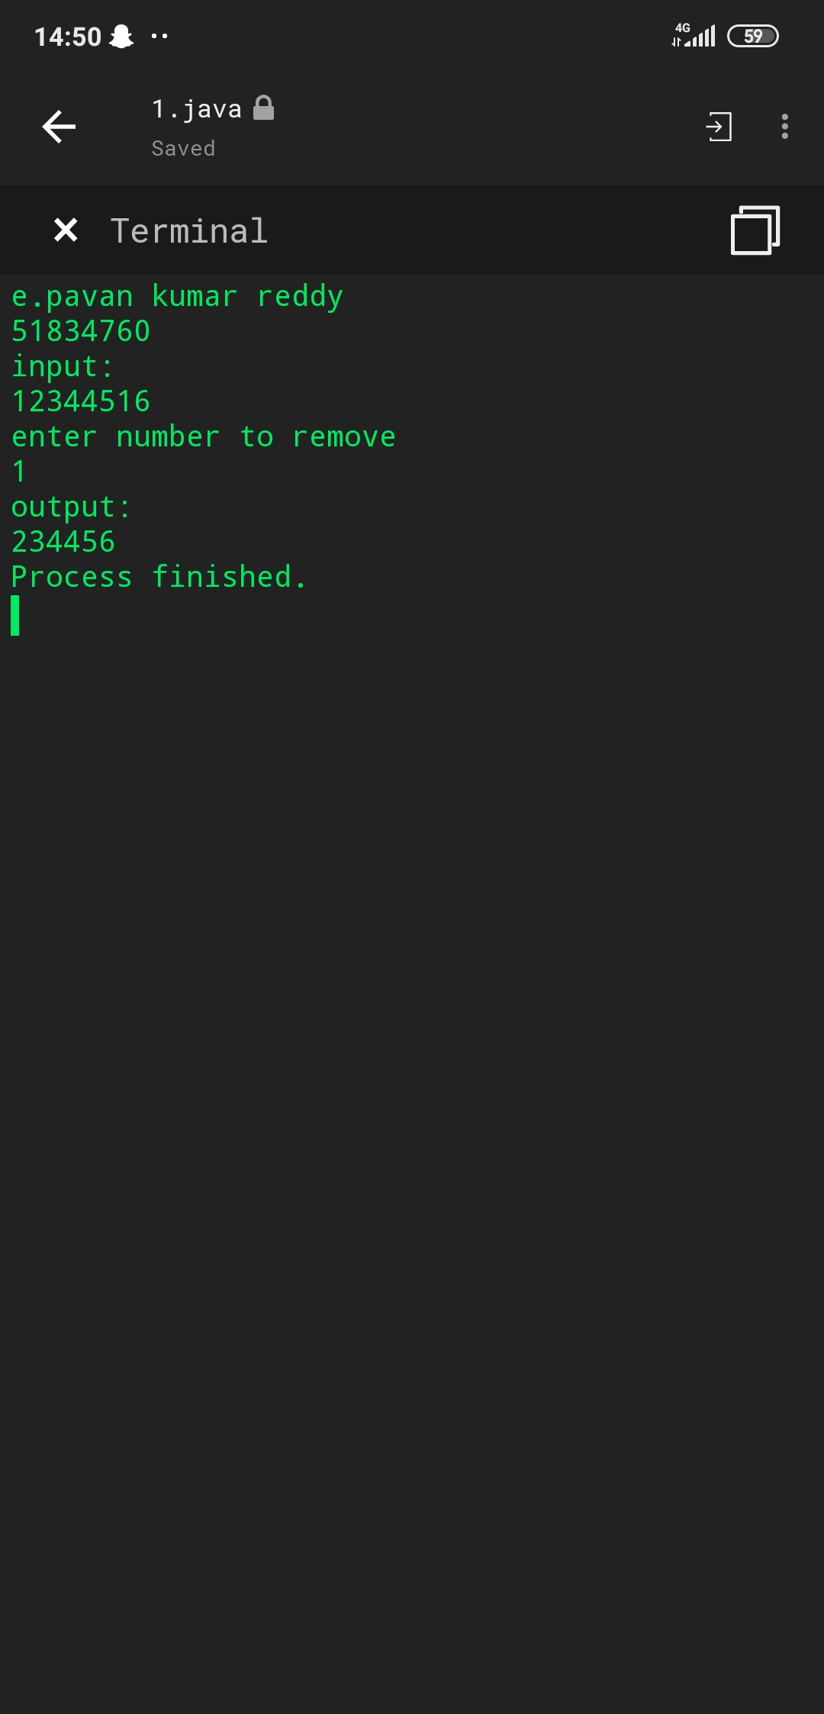

3)
import java.util.*;
class Pavan{
public static void main(String args[]){
Scanner sc=new Scanner(System.in);
System.out.println("enter two strings");
String s1=sc.nextLine();
String s2=sc.nextLine();
s1=s1+s1;
if(s1.contains(s1)){
System.out.println("true");
}
else{
System.out.println("false");
}
}
}

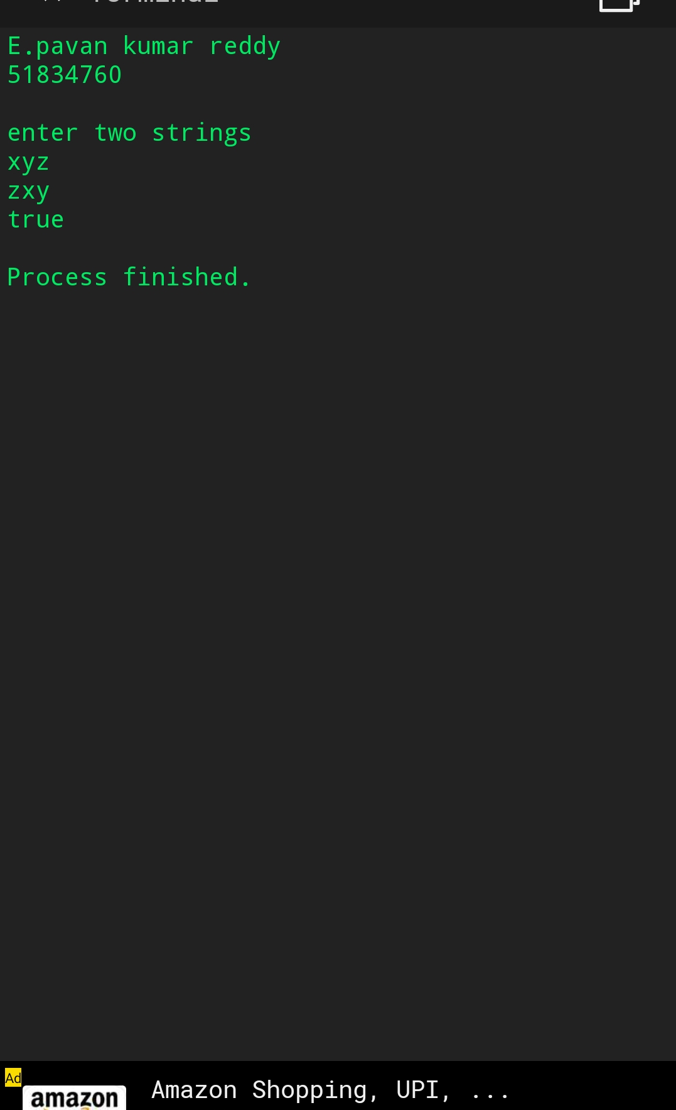

5)
import java.util.*;
class Pavan{
public static void main(String[] args){
Scanner sc=new Scanner(System.in);
System.out.println("E.pavan kumar reddy\n51834760\n");
String arr[]={"hello","pavan","how", "are","you"};
int n=arr.length;
String temp="";
System.out.println("output: ");
for (int j = 0; j < n; j++) {
for (int i = j + 1; i < n; i++) {
// comparing adjacent strings
if (arr[i].compareTo(arr[j]) < 0) {
temp = arr[j];
arr[j] = arr[i];
arr[i] = temp;
}
}
System.out.println(arr[j]);
}

}
}
